PROCEEDINGS, 5th Middle-East Speleology Symposium (MESS5)
Sultan Qaboos University, Muscat, Oman – October 22,23&24, 2024

TITLE OF YOUR PAPER (in CAPITAL LETTERS)
CENTERED ON PAGE, USING ONE OR MORE LINES AS NECESSARY (arial 12pts)

1st Author (in upper and lower case letters)¹, 2nd Author (in upper and lower case letters)²,…
(Arial 10pt)
¹Organization; Short address, City, State or Province, PO Box, Country
²Organization; Short address, City, State or Province, PO Box, Country
E-mail: yourname@yourorganization.xxx

ABSTRACT. The abstract should be typed on this area of the first page; (≤ 250 words, Arial, 10pts, Single spaced).
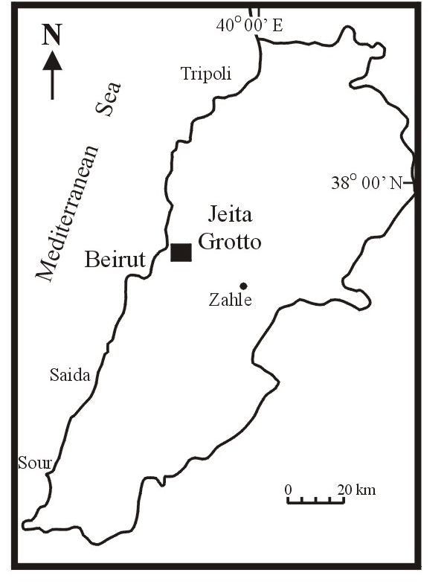
Fig. 1. Illustration, Table, or Equation caption

Keywords: Word1, Word2,… (Maximum 4)

SUBMISSION OF Abstracts
The manuscript (abstract + caption + keywords) are to be sent electronically to info@speleoliban.org.

The templates for preparing papers is available at http://speleoliban.org

INFORMATION
If you have any questions concerning your paper and/or the MESS5, please contact the Symposium Secretariat: (info@speleoliban.org)

